Kitapta 181e kadar oku?

**Chapter 1**

* OS is a resource allocator, manages all resources
* OS is a control program, controls execution of programs to prevent errors and improper use of the computer.
* **Kernel:** The one program running at all times on the computer. The others are system program or application program.
* **Bootstrap Program:** Is loaded at power-up or reboot. Generally known as firmware.
* **Interrupt Vector:** Contains the adresses of all the service routines.
* **Trap or Exception:** Software-generated interrupt caused either by an error or a user request.
* An operating system is interrupt driven.

When a computer system is turned on:

1. **Bootstrap program** is executed.
2. Bootstrap program loads “OS loader” into the memory and transfer control to the OS loader – by changing the IP
3. The OS loader loads the kernel and the other modules of the operating system.

* Multiprogramming needed for efficiency
  + CPU always has one job to execute which selected and run via **job scheduling**
  + Interactive computing
  + Response time < 1
  + Each user has at least one program-executing in memory 🡪 **process**
  + If several jobs ready to run at the same time 🡪 **CPU scheduling**
  + If process don’t fit in memory, **swapping** moves them in and out to run
  + **Virtual memory** helps memory on execution

**Linux Commands**

* **pwd:** Prints working directory
* **cd:** Changes directory. cd pathname
* **ls:** Lists the files in the working directory. Long format: Lists metin içeren bir resim

  Açıklama otomatik olarak oluşturuldu
* **cp:** Copy files and directories.

metin içeren bir resim

Açıklama otomatik olarak oluşturuldu

* **mv:** Move or rename files and directories. metin içeren bir resim

  Açıklama otomatik olarak oluşturuldu
* **rm:** Remove files and directories. metin, tablo içeren bir resim

  Açıklama otomatik olarak oluşturuldu
* **mkdir:** Create directories.
* **rmdir:** Remove directories.
* tablo içeren bir resim

  Açıklama otomatik olarak oluşturuldu
* **chmod:** Change the permission of a file. chmod +x example.sh
* **find:** Serch for files in a directory. find where-to-look criteria what-to-do
* **>:** Redirects the output to the file, overwrites. ls > file_list.txt
* **>>:** Appends the output. Same syntax.
* **<:** Takes input of the file and uses it.
* **sort:** Sorts the contents of the file.
* **|:** Pipeline. Prints commands in order if used.,
* **echo:** printf. $ echo “something”
* **expr:** Arithmetic. $ expr 1 + 3
* **read:** Take input. read fname. echo $fname
* if condition: if condition

then

command1

else

command2

fi

* tablo içeren bir resim

  Açıklama otomatik olarak oluşturuldu
* tablo içeren bir resim

  Açıklama otomatik olarak oluşturuldu
* metin içeren bir resim

  Açıklama otomatik olarak oluşturuldu
* 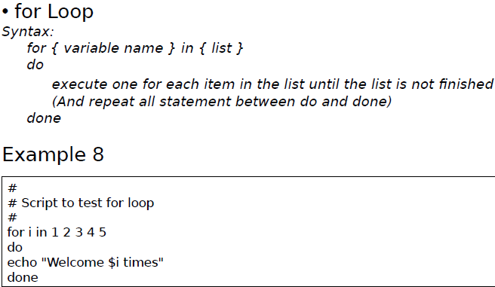
* metin içeren bir resim

  Açıklama otomatik olarak oluşturuldu
* metin içeren bir resim

  Açıklama otomatik olarak oluşturuldu
* metin içeren bir resim

  Açıklama otomatik olarak oluşturuldu